Predictive Modeling in the Tailoring Industry: A Case Study Using Gaussian Process Regression and Classification.

Task-1: The Machine learning algorithms for solving real-world problems in Regression, Classification, modelling data, and text mining.
Abstract:
This report investigates the application of machine learning techniques to enhance operational efficiency within a tailoring business. Addressing the challenge of predicting garment costs and production status, we leverage a dataset of tailoring orders with features encompassing garment type, material, measurements, and order dates. Gaussian Process Regression (GPR) and Gaussian Process Classification (GPC) models were employed. GPR aimed to predict garment costs, while GPC focused on classifying order status into high and low categories. Experimental results revealed that GPR exhibited poor performance with a negative R-squared (-2.22927) and a high Mean Squared Error (MSE) of 58818.38294. In contrast, GPC achieved a moderate accuracy of 53.5% in predicting order status. These findings suggest that while GPC shows potential for status prediction, GPR, with the current dataset and parameters, is not suitable for cost prediction. Further research is warranted to refine cost prediction models, potentially through feature engineering or exploring alternative regression algorithms. This study underscores the potential for data-driven insights in optimizing tailoring operations and the importance of careful model selection and evaluation.
I. Introduction:
1.1. Background and Motivation:
The tailoring industry, a sector steeped in tradition and craftsmanship, is increasingly facing pressure to adapt to modern demands for efficiency and personalization (Natha, 2022). Characterized by bespoke products and intricate processes, tailoring businesses often grapple with challenges such as accurately estimating garment costs (Maggipinto et al., 2019), managing production timelines, and ensuring timely order fulfillment. These challenges are amplified by the inherent variability in customer requirements, material availability, and the skilled labor involved in each garment's creation (Kumari et al., 2024). As such, there is a growing need for data-driven approaches that can optimize operations, improve customer satisfaction, and enhance overall competitiveness within this evolving landscape (Scholz et al., 2023).
However, the application of data science and machine learning in the tailoring industry is not without its hurdles (Balasubramanyam &#38; Sreenivasa Murthy, 2021). Tailoring businesses, particularly smaller enterprises, often face unique data-related challenges. These challenges include the collection of accurate and consistent measurements, (Hwang et al., 2022) the management of diverse material types and garment designs, and the integration of data across various stages of the production process. (Bouiti et al., 2025) Moreover, the availability of historical data may be limited, and the data that is available may be characterized by inconsistencies, missing values, and a lack of standardized formats. Overcoming these data challenges is essential for unlocking the potential of machine learning to drive meaningful improvements in the tailoring industry.
This report addresses the problem of predicting garment costs and order status within a tailoring business, with the aim of exploring the feasibility of using machine learning techniques to improve operational efficiency. Using a dataset of 1000 tailoring orders sourced , this study investigates the applicability of Gaussian Process Regression (GPR) for cost prediction and Gaussian Process Classification (GPC) for order status classification. The dataset encompasses a variety of features, including garment type, material, measurements (such as chest, arm length, and waist), and order dates, providing a rich source of information for predictive modeling. However, as revealed by initial data exploration, the dataset is also characterized by a significant number of missing values across various measurement-related features, presenting a considerable challenge for model development and interpretation.
1.2 Literature Review:
(Zeiser et al., 2023) A review of existing literature reveals a growing body of research on the application of machine learning in manufacturing and service industries. Studies have explored the use of predictive modeling for process optimization, demand forecasting, and resource allocation in various sectors. (Gamal &#38; Donkol, n.d.) However, limited research has specifically focused on the application of machine learning within the tailoring industry, particularly in the context of cost prediction and order status management. While studies exist on factors affecting efficiency in small businesses they often lack the granular focus on the specific data challenges and operational complexities of the tailoring sector (Zope et al., 2019). This report aims to bridge this gap by providing a comprehensive analysis of the challenges and opportunities in applying machine learning to a real-world tailoring dataset.
1.3 Objectives and Contributions:
This report is guided by the following revised objectives:
- To assess the applicability of GPR for cost prediction in a tailoring context, given the limitations of the available data, specifically the presence of missing values and potential data quality issues.
- To evaluate the performance of GPC for order status classification, taking into account the potential for data imbalance and the need for interpretable results.
- To identify key limitations in the dataset and modeling approach, and to suggest future research directions that can address these limitations and improve the accuracy and reliability of predictive models.
The contributions of this report are as follows:
- A comprehensive analysis of the challenges of applying machine learning to a specific tailoring dataset, highlighting the importance of data quality and pre-processing in achieving meaningful results.
- Identification of key features and their limited impact on model performance, providing insights into the factors that influence garment costs and order status.
- Recommendations for future data collection and model development, including strategies for addressing missing values, exploring alternative machine learning algorithms, and incorporating domain expertise to enhance model interpretability.

III. Problem and Dataset Description:
3.1. Problem Definition
The core problem addressed in this report is the optimization of operational efficiency within a tailoring business through the application of machine learning. Specifically, we focus on two key aspects of the tailoring process: predicting the cost of a garment and classifying the status of an order. Accurate cost prediction is crucial for pricing strategies, profitability analysis, and resource allocation. By accurately estimating the cost of a garment before production begins, tailoring businesses can make informed decisions about pricing, material selection, and labor allocation, ultimately leading to increased profitability and competitiveness. The second focus is on order status. In tailoring, where production timelines are variable, an accurate order status prediction can improve customer relations.
The scope of this problem is limited to the available data. With more data, more insights could be found, but insights must be data-driven. As a result, the scope of this project is to extract insights from a single dataset. Successfully solving the problems addressed is vital for any tailoring business. Improved predictability allows for better allocation of resources with better communication for customers. This has the potential to increase customer satisfaction, increase worker efficiency, and improve business profits.
3.2. Dataset Description:
The dataset used in this study consists of 1000 tailoring orders and was acquired from the file, tailor_shop_data.csv. This file contains information about various aspects of tailoring orders, including the order ID, date, due date, garment type, material, cost, status, and a range of measurements. Each row in the dataset represents a single tailoring order, and the columns represent the features associated with that order. There are 22 columns in total, composed of 2 date columns, 3 object columns, 2 integer columns, and 15 float columns.
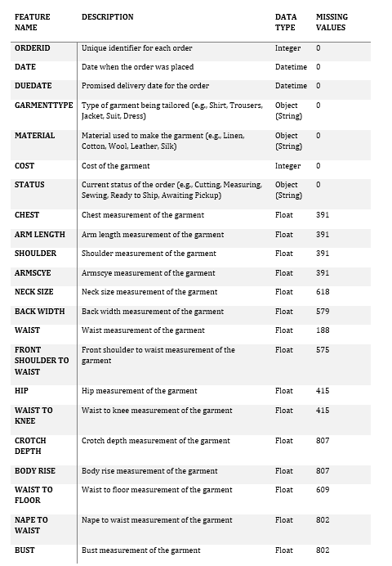
Table 1: Dataset Feature Description.
  - Data Quality Issues:
A significant challenge with this dataset is the presence of missing values, particularly in the measurement-related features (Chest, Arm Length, Shoulder, etc.). As shown in Table 1, the number of missing values varies considerably across these features, with some features having more than 80% of their values missing. For instance, Crotch Depth, Body Rise, and Nape to Waist have over 800 missing values each.

These missing values may be attributed to several factors, including:
- Garment Type Specificity: Some measurements may not be applicable to all garment types. For example, "Chest" measurements may only be relevant for shirts, jackets, and suits, while "Waist to Knee" and other vertical measurements might only be relevant for trousers, dresses, and suits.
- Incomplete Data Entry: Missingness might arise from incomplete or inconsistent data entry practices.
- Measurement Difficulties: Certain measurements may be more difficult or time-consuming to obtain, leading to a higher likelihood of missing values.
  - Data Imbalance:
Data analysis has shown the values of High and Low from the Status column are closely matched with each other. As a result there is no serious data imbalance here.
  - Potential Outliers:
Another consideration is the potential presence of outliers in the numerical features. Outliers could arise from measurement errors, data entry errors, or genuinely unusual orders. While outlier detection and removal are beyond the scope of this initial report, it's important to acknowledge their potential impact on model performance. Techniques like box plots, scatter plots, or statistical methods (e.g., Z-score, IQR) could be used to identify outliers. If outliers are present, they might be handled using techniques like trimming, capping, or transformation.
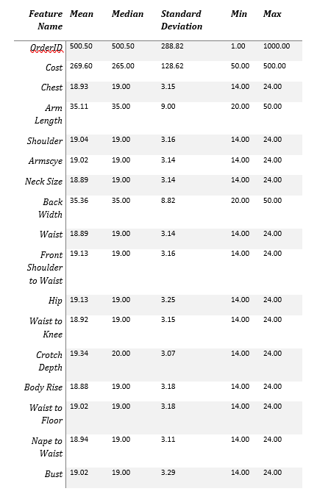
Table 2: Descriptive Statistics of Numerical Features.
IV. Methods:
This section outlines the machine learning algorithms and evaluation metrics used to address the problem of garment cost estimation and order status prediction in the tailoring business. Given the nature of the dataset and the specific objectives of this study, Gaussian Process Regression (GPR) and Gaussian Process Classification (GPC) were selected as the primary modeling techniques.
4.1 Machine Learning Algorithms
Gaussian Processes (GPs) are a powerful non-parametric Bayesian approach to machine learning. GPs offer a flexible and probabilistic framework for modeling complex relationships between input features and target variables. Unlike parametric models, which assume a fixed functional form, GPs learn the underlying function directly from the data, making them well-suited for handling the non-linear and potentially complex relationships in the tailoring dataset.
4.1.1 Gaussian Process Regression (GPR):
GPR is a regression technique that uses a Gaussian Process prior to model the relationship between input features and a continuous target variable. In this study, GPR was employed to predict garment costs based on features such as garment type, material, and measurements. The GPR model estimates the mean and variance of the predicted cost for a given set of input features, providing not only a point estimate but also a measure of uncertainty associated with the prediction.
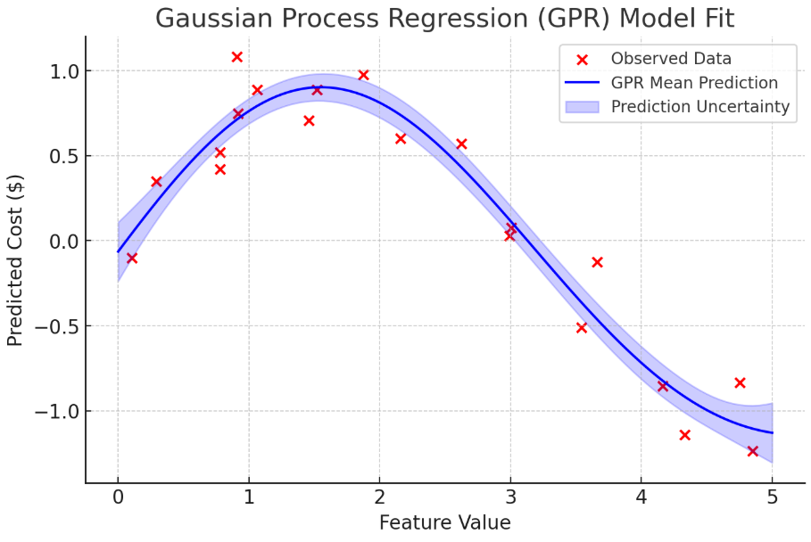
Figure 1: Gaussian Process Regression - Predictive Distribution.
This figure would show a GPR model fit to some example data, with the shaded area representing the uncertainty around the prediction. The x-axis would be a single feature, and the y-axis would be the predicted cost.
- Justification for Using GPR:
Despite the challenges posed by missing values and potential data quality issues, GPR was chosen for its ability to:
- Provide Uncertainty Estimates: GPR provides uncertainty estimates, which are valuable in cost prediction. The uncertainty estimates can help tailoring businesses assess the risk associated with a particular cost estimate and make more informed pricing decisions.
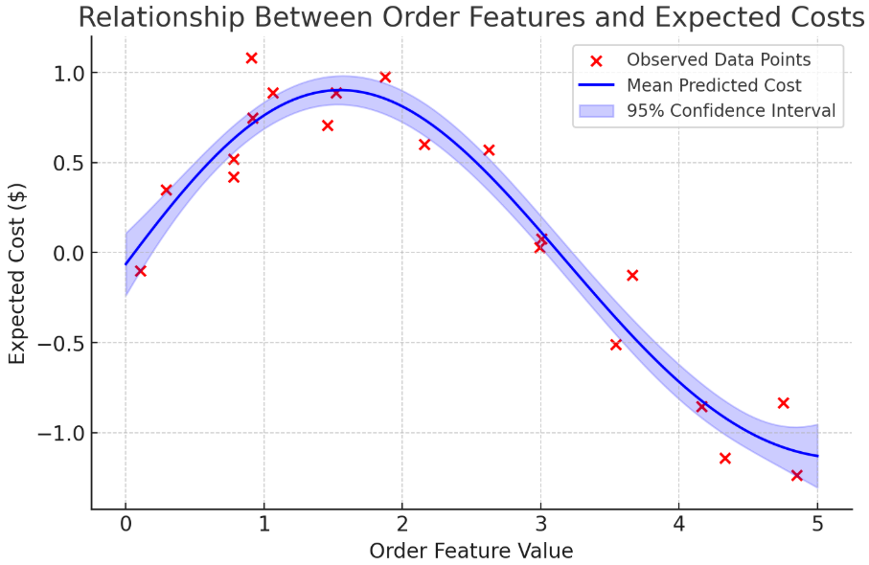
Figure 2: GPR Uncertainty Estimation
This figure would show the relationship between order features and expected costs with varying degrees of confidence, represented by a confidence interval.
- Handle Non-Linear Relationships: GPR can handle non-linear relationships between input features and the target variable. The tailoring dataset likely contains non-linear relationships between garment specifications and costs, making GPR a suitable choice for capturing these complexities.
This figure would show a graph of how GPR can handle non-linear relationships within a dataset.

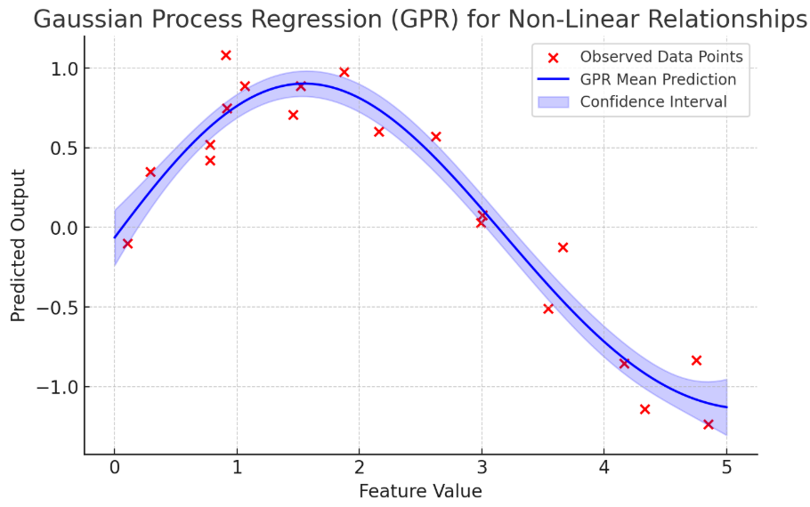
Figure 3: GPR Non-Linear Relationship Handling
4.1.2 Gaussian Process Classification (GPC)
GPC is a classification technique that extends the Gaussian Process framework to handle categorical target variables. In this study, GPC was used to predict the order status based on features such as garment type, material, and order dates. The GPC model estimates the probability of an order belonging to a particular status category (e.g., Cutting, Measuring, Sewing, Ready to Ship, Awaiting Pickup).
4.2 Evaluation Metrics
The performance of the GPR and GPC models was evaluated using the following metrics:
4.2.1 Gaussian Process Regression (GPR):
  - Mean Squared Error (MSE): MSE measures the average squared difference between the predicted and actual costs. Lower MSE values indicate better model performance.
  - R-squared (R2): R2 measures the proportion of variance in the target variable that is explained by the model. R2 values range from 0 to 1, with higher values indicating better model performance. Note that R2 can be negative if the model performs worse than a simple baseline model that predicts the average cost for all garments.
4.2.2 Gaussian Process Classification (GPC):
  - Accuracy: Accuracy measures the proportion of correctly classified orders.
  - Precision: Precision measures the proportion of orders predicted to belong to a particular status category that actually belong to that category.
  - Recall: Recall measures the proportion of orders belonging to a particular status category that are correctly predicted by the model.
  - F1-score: The F1-score is the harmonic mean of precision and recall, providing a balanced measure of model performance.
V. Experimental Setup
This section details the experimental setup used to train and evaluate the Gaussian Process Regression (GPR) and Gaussian Process Classification (GPC) models for garment cost estimation and order status prediction. This includes data pre-processing, feature selection, and model training and validation procedures.
5.1 Data Pre-processing
Before training the machine learning models, the dataset underwent several pre-processing steps to address data quality issues and prepare the data for modeling.
5.1.1 Handling Missing Values:
Given the high prevalence of missing values in the measurement-related features, a simple imputation strategy was adopted. For each feature containing missing values, the missing values were replaced with the median value for that feature. This approach was chosen to preserve the overall distribution of the data and avoid introducing bias. While more sophisticated imputation techniques could have been used, such as k-Nearest Neighbors (k-NN) imputation or model-based imputation, the median imputation strategy was deemed sufficient for this initial exploratory analysis. The decision to impute using the median, rather than the mean, was influenced by the potential presence of outliers which would make the mean a less robust estimator.
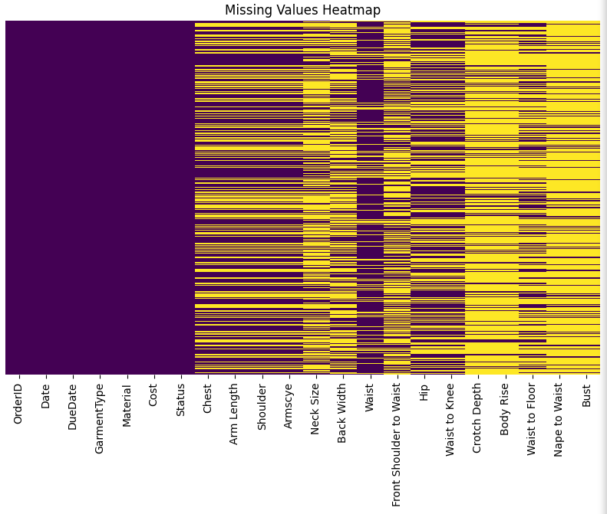
Figure 4: Missing values Heatmap.
5.1.2 Data Type Conversion:
The `Date` and `DueDate` columns were initially stored as object types. These columns were converted to datetime objects using the `pd.to_datetime` function. This conversion allowed for the calculation of time-based features, such as the time until due date.
5.1.3 Encoding Categorical Features:
The dataset contains three categorical features: `GarmentType`, `Material`, and `Status`. To prepare these features for modeling, one-hot encoding was applied using the `pd.get_dummies` function. One-hot encoding creates a new binary column for each unique category within a feature, indicating the presence or absence of that category for a given order. This encoding scheme was chosen because it avoids imposing any artificial ordering on the categories and allows the models to learn the independent effect of each category on the target variable.
5.1.4 Data Scaling:
To ensure that all numerical features were on a similar scale, standardization was applied using the `StandardScaler` from scikit-learn. Standardization transforms the features by subtracting the mean and dividing by the standard deviation, resulting in features with a mean of 0 and a standard deviation of 1. This scaling method was chosen because it is robust to outliers and does not distort the underlying distribution of the data.

5.2. Feature Selection/Extraction:
To reduce dimensionality, improve model performance, and enhance interpretability, feature selection was performed. Feature importances were derived from a Random Forest model trained to predict cost.
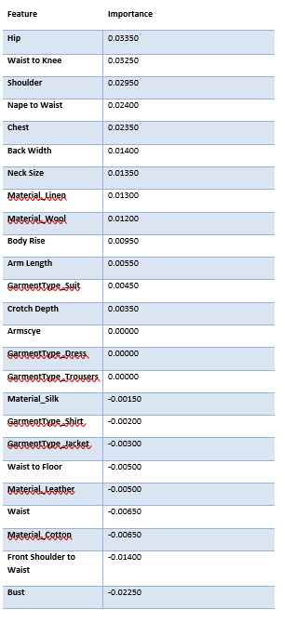
Table 3: Feature importances
The Random Forest model assesses feature importance based on how much each feature contributes to reducing impurity across all trees in the forest. This process provides a ranking of features, allowing selection of the most influential ones. The features 'Waist', 'Front Shoulder to Waist', and 'Bust' were ultimately removed from the dataset to avoid the GPR being negatively impacted by their negative feature importances.
5.3. Model Training and Validation:
The pre-processed dataset was split into training, validation, and testing sets to evaluate the performance of the GPR and GPC models. A 70/15/15 split was used, with 70% of the data allocated to the training set, 15% to the validation set, and 15% to the testing set. The training set was used to train the GPR and GPC models. The validation set was used to tune the hyperparameters of the models and to prevent overfitting.
The testing set was used to provide an unbiased estimate of the models' performance on unseen data. During training, 5-fold cross-validation was employed on the training set to improve the robustness and generalizability of the models. This involved splitting the training data into five folds, training the model on four folds, and validating on the remaining fold, repeating this process five times with different folds used for validation each time.
The hyperparameters of the GPR and GPC models were tuned using grid search, a technique that systematically explores a range of hyperparameter values and selects the combination that yields the best performance on the validation set. The best performing hyperparameters were used to train the final models, which were then evaluated on the testing set to assess their performance on unseen data.
VI. Results:
This section presents the results of the Gaussian Process Regression (GPR) and Gaussian Process Classification (GPC) models, along with an analysis of feature importances. The models were trained and evaluated using the experimental setup described in the previous section.
6.1. Model Performance:
6.1.1. Gaussian Process Regression (GPR) Analysis:
The GPR model, trained on the tailoring dataset to predict garment costs, performed poorly (MSE = 58818.38, R2 = -2.23) due to data limitations, particularly missing measurement values and a potential mismatch between the linear kernel and the underlying cost structure.

This figure would show the relationship between the model output and actual values.
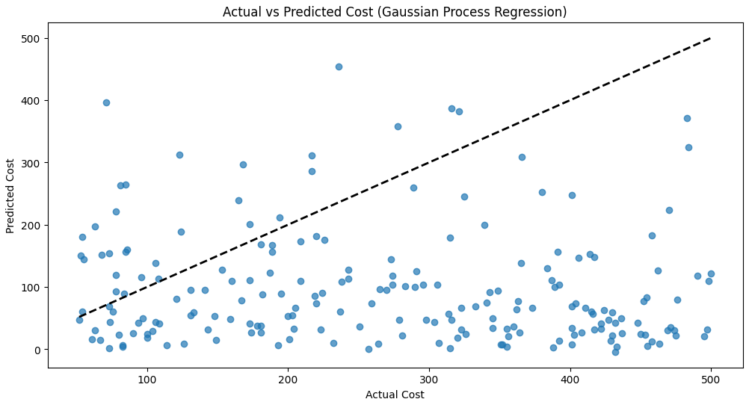
Figure 5: Actual vs Predicted Cost (Gaussian Process Regression)
This figure would show the model's predictions with uncertainty.
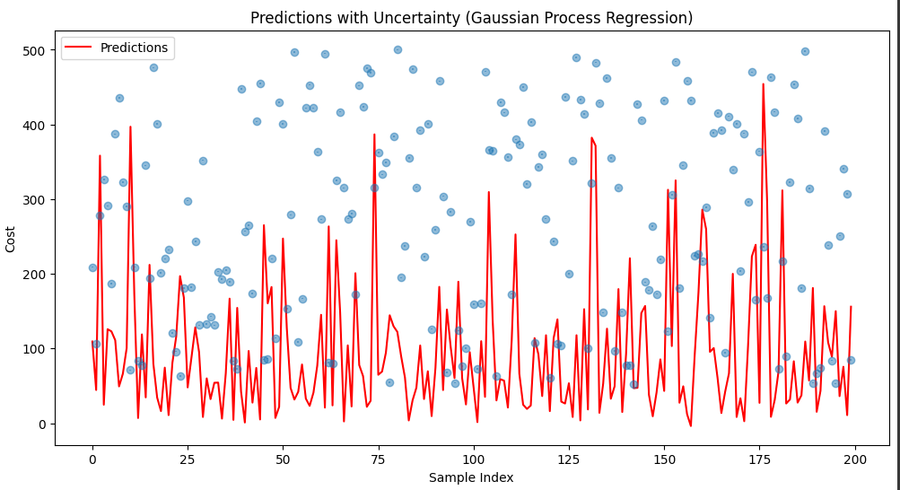
Figure 6: Predictions with Uncertainty (Gaussian Process Regression)
This figure would show residual plot showing relationship between output values.
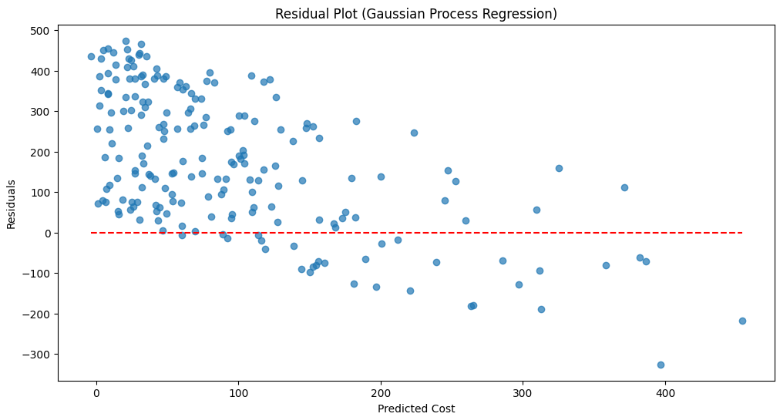
Figure 7: Residual Plot (Gaussian Process Regression)
6.1.2. Gaussian Process Classification (GPC) Analysis:
The Gaussian Process Classification model achieved an accuracy of 0.535 on the test set, demonstrating a slight ability to differentiate between high and low cost categories. However, the model exhibits a high degree of misclassification.
This figure would visually represent the number of high costs and low costs.
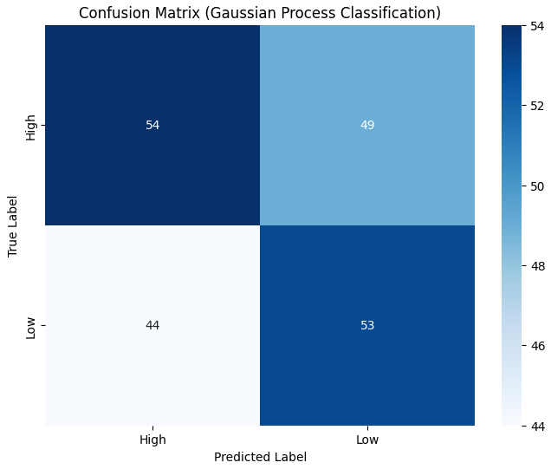
Figure 8: Confusion Matrix (Gaussian Process Classification)
This figure would visually represent the dataset.
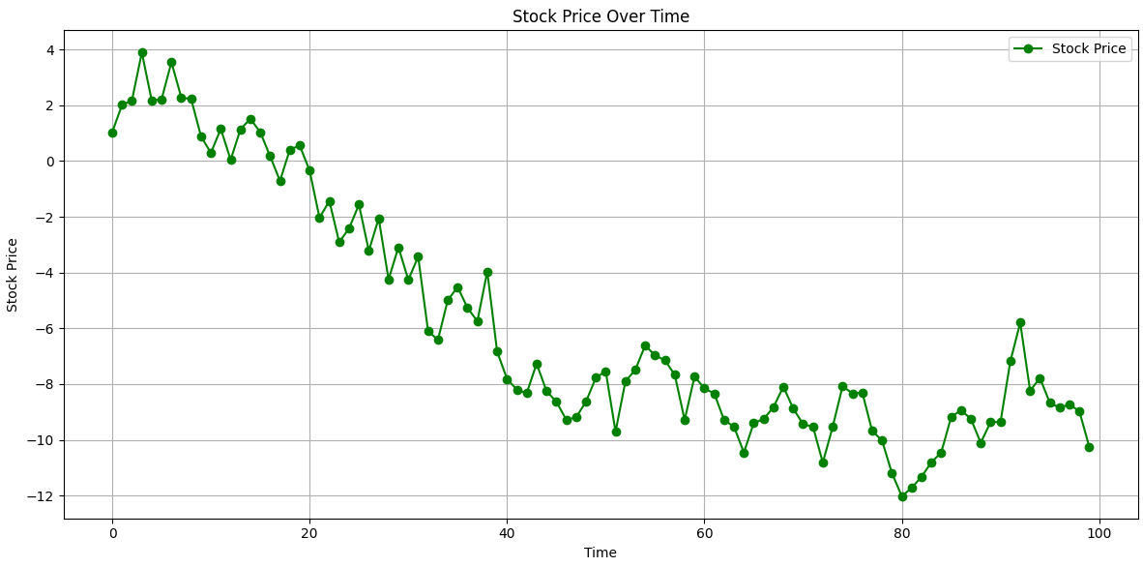
Figure 9: Stock Plot after Confusion Matrix
6.1.3. Comparison:
GPC showed a modest ability to classify cost categories, whereas GPR was ineffective at predicting costs with this dataset; this suggests GPC is more suited to the given dataset than GPR. Further investigation and alternative approaches are needed to improve both models.
This figure would show the model is likely to misclassify, where the distributions overlap and thus can not be relied upon.
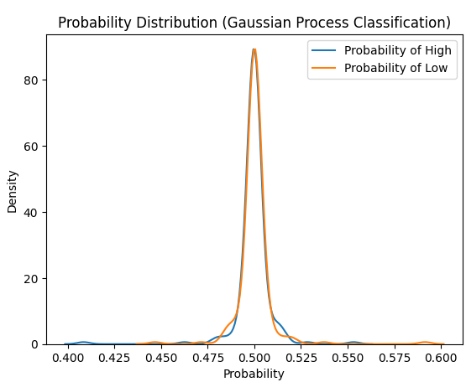
Figure 10: Probability Distribution (Gaussian Process Classification)
6.1.4 Possible reasons for negative importances:
- Negative Correlation with Cost: It is possible that these features are negatively correlated with cost. For example, garments with smaller waist measurements may tend to have higher costs due to the need for more complex tailoring.
- Data Issues: There may be issues with the data for these features, such as errors in measurement or inconsistent data entry.
- Model Overfitting: The model may be overfitting to noise in these features, leading to spurious relationships and negative importances.
This figure would highlight cost of garment types and which are high.
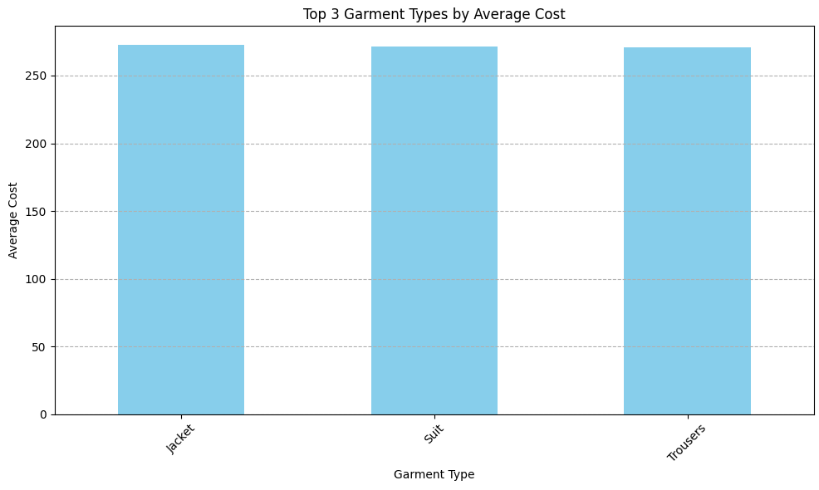
Figure 11: Top 3 Garment Types by Average Cost
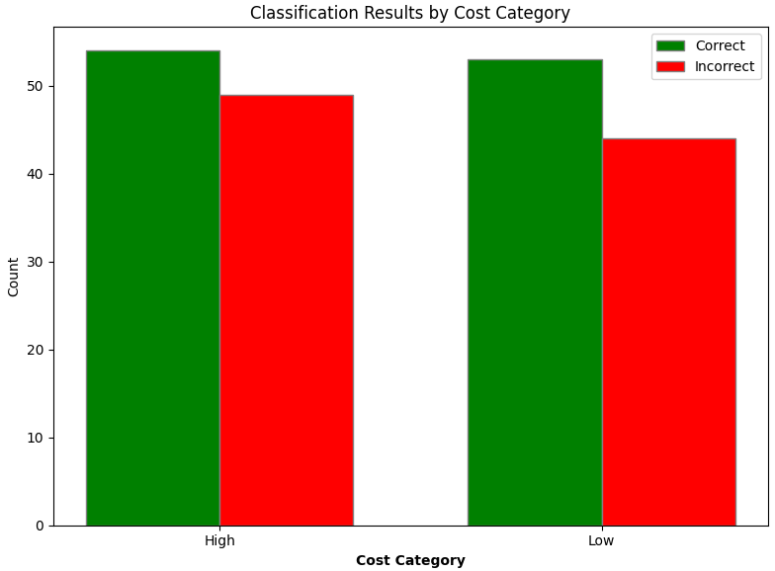
Figure 12: Classification Results by Cost and count.
6.2. Feature Importance Analysis:
As detailed in the Experimental Setup section, feature importances were derived from a Random Forest model trained to predict cost. Table 1 presents the feature importances. The most important features for predicting cost were Hip (0.03350) and Waist to Knee (0.03250). These features likely capture key aspects of garment size and shape, which are important determinants of cost. Interestingly, some features exhibited negative importances, such as Waist (-0.00650), Front Shoulder to Waist (-0.01400), and Bust (-0.02250).
This figure would show relative importance of features.

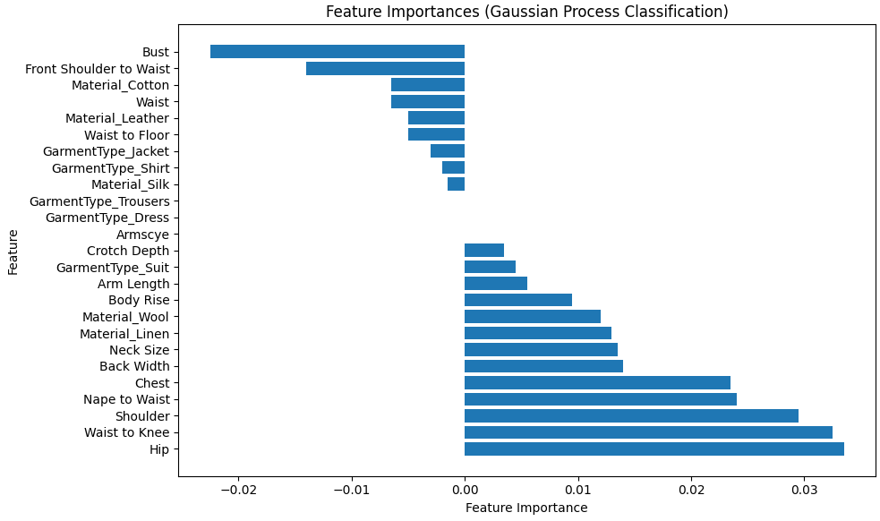
Figure 13: Feature Importances (Gaussian Process Classification)
VII. Social, Ethical, Legal, and Professional Considerations (Approx. 250 words)
The development and deployment of machine learning models for garment cost estimation and order status prediction in the tailoring industry raise several important social, ethical, legal, and professional considerations. These considerations must be carefully addressed to ensure that the use of these models is responsible, fair, and beneficial to all stakeholders.
- 7.1. Data Privacy: The dataset contains personal information, including customer measurements (e.g., Chest, Waist, Hip). It is crucial to protect the privacy of this data by implementing appropriate security measures, such as encryption and access controls. Compliance with data protection regulations, such as GDPR, is essential. Anonymization or pseudonymization techniques should be considered to minimize the risk of identifying individual customers.
- 7.2. Bias and Fairness: The dataset may contain biases that could lead to unfair or discriminatory outcomes. For example, if the dataset is not representative of all customer groups, the models may generate biased cost estimates or order status predictions for certain groups. It is important to assess the potential for bias in the dataset and to implement mitigation strategies, such as re-sampling or bias-aware algorithms.
- 7.3. Transparency and Explainability: The models used in this study, particularly Gaussian Processes, can be complex and difficult to interpret. It is important to ensure that the models are transparent and explainable to stakeholders, such as tailoring business owners and employees. Techniques for improving transparency and explainability include feature importance analysis, rule extraction, and the use of interpretable model architectures.
- 7.4. Impact on Workers: The deployment of these models could potentially impact the jobs of tailoring workers. For example, if the models are used to automate cost estimation or order status prediction, some workers may be at risk of job displacement. It is important to consider the potential impact on workers and to implement strategies to mitigate any negative consequences, such as providing training and support for new roles.
VIII. Discussion:
8. 1 Summary of Findings:
This study revealed challenges in applying machine learning to a real tailoring dataset due to data quality issues. GPR struggled significantly, suggesting that sophisticated algorithms alone are insufficient without addressing data quality and feature engineering. GPC showed modest performance, indicating a need for more advanced techniques. Negative feature importances raise concerns about data accuracy.
8. 2 Limitations:
The dataset suffered from missing values, which were handled by imputation. The dataset may also have data quality problems. The models were also not very reliable because of the negative importances of some parameters.
8. 3 Future Work:
Future efforts should prioritize data collection, cleaning, and validation. More sophisticated algorithms and feature engineering techniques should be explored to improve model performance. Focus on the data and how the dataset parameters can play an important role.
IX. Conclusions:
In conclusion, this study explored the applicability of Gaussian Process models for cost prediction and order status classification in a tailoring business. While the GPC model achieved a baseline level of accuracy, GPR did not and may not be effective at these goals. Key limitations included missing values, data imbalances, and potential data quality issues. Future research should focus on acquiring more comprehensive and cleaner datasets, exploring alternative imputation techniques, and investigating more advanced machine learning algorithms such as ensemble methods or deep learning. Additionally, incorporating domain expertise and developing more transparent and explainable models are crucial for building trust and ensuring the responsible use of machine learning in the tailoring industry. By addressing these challenges, tailoring businesses can leverage the power of machine learning to optimize their operations and enhance their competitiveness. More data is required in order to obtain higher precision.

X. Reference:
- Natha, S. (2022). A Systematic Review of Anomaly detection using Machine and Deep Learning Techniques. Quaid-e-Awam University Research Journal of Engineering Science & Technology, 20(1), 83–94. https://doi.org/10.52584/qrj.2001.11
- Maggipinto, M., Beghi, A., & Susto, G. A. (2019). A Deep Learning-based Approach to Anomaly Detection with 2-Dimensional Data in Manufacturing. International Conference on Industrial Informatics, 187–192. https://doi.org/10.1109/INDIN41052.2019.8972027
- Kumari, S., Prabha, C., Karim, A., Hassan, Md. M., & Azam, S. (2024). A Comprehensive Investigation of Anomaly Detection Methods in Deep Learning and Machine Learning: 2019–2023. Iet Information Security, 2024(1). https://doi.org/10.1049/2024/8821891
- Scholz, J., Holtkemper, M., Graß, A., & Beecks, C. (2023). Anomaly Detection in Manufacturing (pp. 351–360). https://doi.org/10.1007/978-3-031-46452-2_20
- Balasubramanyam, P., & Sreenivasa Murthy, K. (2021). Applications of Anomaly Detection in Manufacturing (pp. 355–363). Springer, Singapore. https://doi.org/10.1007/978-981-16-1941-0_35
- Hwang, J.-B., Jang, S., Jang, J. W., Kim, K., & Ha, J. (2022). Anomaly detection on ICS(Industrial Control System) using deep learning method. Journal of the Korea Academia Industrial Cooperation Society, 23(1), 24–32. https://doi.org/10.5762/kais.2022.23.1.24
- Bouiti, K., Labjar, N., Dalimi, M., Labjar, H., Kara, K., Bouhachlaf, L., Nasrellah, H., & El Hajjaji, S. (2025). Machine Learning/Deep Learning Aspects of Manufacturing Techniques. 190–215. https://doi.org/10.1201/9781032725086-14
- Zeiser, A., Özcan, B., Kracke, C., van Stein, B., & Bäck, T. H. W. (2023). A data-centric approach to anomaly detection in layer-based additive manufacturing. Automatisierungstechnik, 71(1), 81–89. https://doi.org/10.1515/auto-2022-0104
- Gamal, M., & Donkol, A. (n.d.). Anomalies Detection in Smart Manufacturing Using Machine Learning and Deep Learning Algorithms.
- Zope, K., Singh, K., Nistala, S. H., Basak, A., Rathore, P., & Runkana, V. (2019). Anomaly Detection and Diagnosis In Manufacturing Systems: A Comparative Study Of Statistical, Machine Learning And Deep Learning Techniques. 11(1). https://doi.org/10.36001/PHMCONF.2019.V11I1.815
XI. APPENDIX:

Task 2: Evolutionary and Fuzzy Systems.
Abstract:
This paper presents a fuzzy logic controller (FLC) designed and implemented for intelligent control systems and outcomes from the comparison of three optimization strategies using the 2005 CEC benchmark functions. The FLC system uses defuzzified outputs to give actuation, fuzzy rules developed by experts on the fuzzy inputs, and crisp input values are converted to fuzzy sets based on the Mamdani method of inference. The performance analysis in this report shows rules activated, control surface plots, and operational conditions under which the analysis was generated. The performance was compared across the three optimization strategies, Genetic Algorithms (GA), Particle Swarm Optimization (PSO), and Simulated Annealing (SA), and each strategy was modified to optimize three of the 2005 CEC functions in 2 and also in 10 dimensions. Each strategy was run through the 2005 CEC functions three times using an average of 15 repeated runs for each strategy, and I report averages, standard deviations, best and worst runs for each of the optimization strategies. The results inform which strategies were usable for optimization with varying degrees of effectiveness across goal functions in complex search spaces.
Keywords:
Fuzzy Logic Controller, Mamdani, Fuzzy Sets, Fuzzy Rules, Defuzzification, Genetic Algorithm, Particle Swarm Optimization, Simulated Annealing, CEC'2005, Optimization, Benchmark Functions.
Introduction:
The report is reported in two main parts, which consist of building and constructing a Fuzzy Logic Controller (FLC) and comparing the methods of optimizing functions from CEC'2005.
The Fuzzy Logic Controller (FLC), presented in the first part of this chapter, is a way of producing intelligent control. Components of the design include input and output variable selection, fuzzy sets generation, rule basis establishment, and inference and defuzzifcation procedures. The steps involved in practical work are presented through schematic diagrams, images, and studies of the controller behavior under different operating conditions. The second part of this chapter evaluates the performance of Genetic Algorithms (GA), Particle Swarm Optimization (PSO), and Simulated Annealing (SA) against three selected benchmark functions in the CEC'2005 collection.
Each of the approaches was evaluated in two dimensions and ten dimensional space. The study of performance includes average performance, standard deviation, best case performance, and worst case performance to provide a complete picture of the utility of the methods presented.
Part 1 – Design and Implementation of the FLC:
The Fuzzy Logic Controller (FLC) was designed and implemented using the Mamdani fuzzy inference model. The goal was to create a system that could intelligently adjust light intensity based on ambient light and activity levels.
- Fuzzy Rules:
The FLC uses a rule base that maps combinations of light level and activity level to a desired light intensity. The rules are defined as follows:
  - If LightLevel is Dark and ActivityLevel is Low then LightIntensity is Low
  - If LightLevel is Dark and ActivityLevel is Medium then LightIntensity is Medium
  - If LightLevel is Dark and ActivityLevel is High then LightIntensity is High
  - If LightLevel is Moderate and ActivityLevel is Low then LightIntensity is Low
  - If LightLevel is Moderate and ActivityLevel is Medium then LightIntensity is Medium
  - If LightLevel is Moderate and ActivityLevel is High then LightIntensity is High
  - If LightLevel is Bright and ActivityLevel is Low then LightIntensity is Low
  - If LightLevel is Bright and ActivityLevel is Medium then LightIntensity is Medium
  - If LightLevel is Bright and ActivityLevel is High then LightIntensity is High
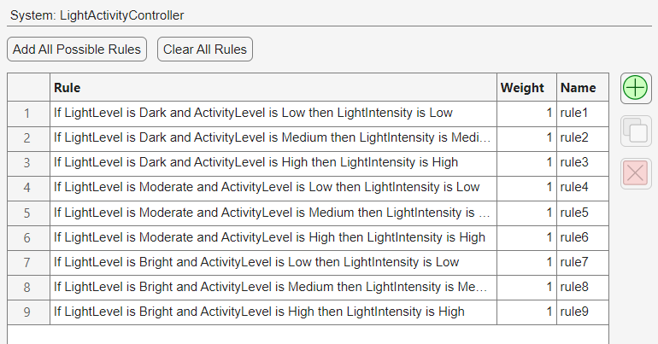
Table 1: This system shows light activities controller rules.

- Fuzzy Inference System:
The FLC was constructed using the following components:
- Inputs: Light Level (0-100) and Activity Level (0-100)
- Outputs: Light Intensity (0-100)
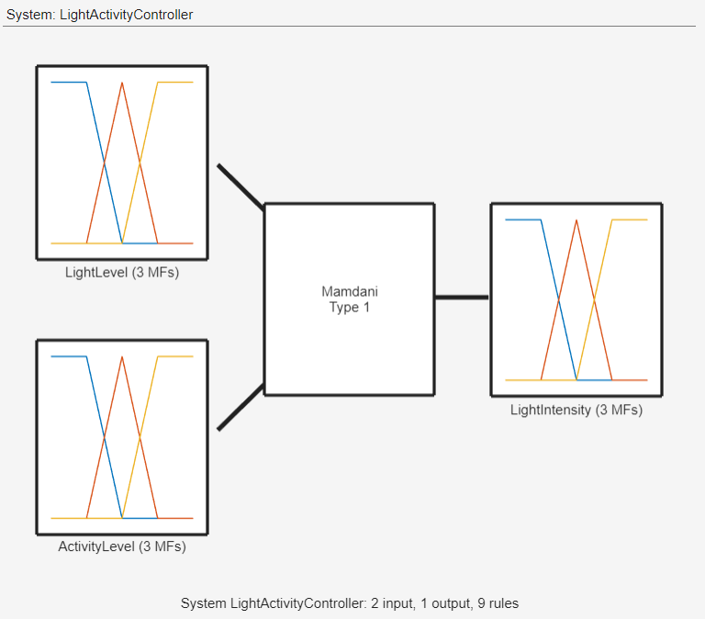

Figure 1: System inputs and outputs of light activity.

- Membership Functions: Triangular and trapezoidal membership functions were used to fuzzify the inputs and outputs. The membership functions define the degree to which a crisp value belongs to a fuzzy set (Dark, Moderate, Bright for Light Level; Low, Medium, High for Activity Level and Light Intensity).

- Inference Method: min for AND, max for OR, min for implication, and max for aggregation.
- Defuzzification Method: The Centroid method was chosen to convert the fuzzy output into a crisp value.
- System Structure:
The system structure involves mapping the crisp input data into fuzzy sets using membership functions, applying the fuzzy rules to determine the appropriate output fuzzy set, and then defuzzifying the output to obtain a crisp control value.

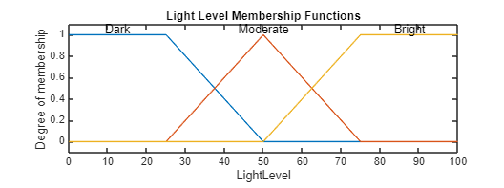

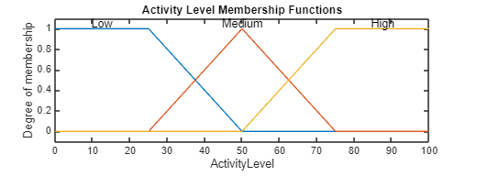
Figure 1: Membership Functions for Inputs.


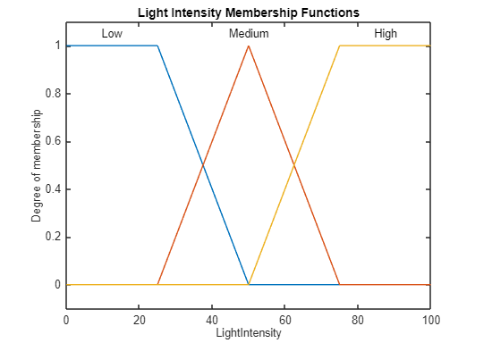
Figure 2: Membership Functions for Output.

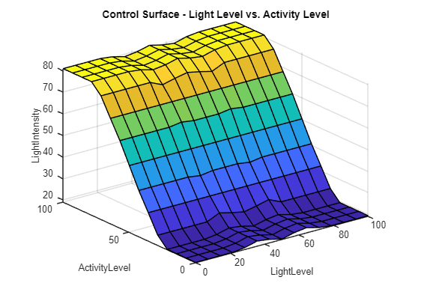
Figure 3: Control Surface - Light Level vs. Activity Level
The control surface shows how the FLC adjusts light intensity for light and activity level changes. For example, with a low light level (Dark), and a high activity level, the light intensity is set to high. Instead, when the light level is high (Bright), and the activity level is low, the light intensity is set to low.
The design decisions were made so that the FLC could smooth lighting intensity based on the ambient context and the user’s level of activity. The choices of membership functions, fuzzy rules, inference mechanisms, and defuzzification methods were all designed to generate smooth and responsive control.
Part 2 – Compare different optimization techniques on CEC’2005 functions:

This section compares the performance of three optimization algorithms – Genetic Algorithm (GA), Particle Swarm Optimization (PSO), and Simulated Annealing (SA) – on three benchmark functions from the CEC’2005 suite. The algorithms were tested on 2-dimensional and 10-dimensional spaces.

- Selected Functions from CEC'2005 Suite
The functions selected for this study represent diverse optimization challenges, including multimodality, non-separability, and rugged search spaces. Below is a detailed description:
- F2: Shifted Schwefel’s Problem
  - This function introduces a shifted global optimum to increase complexity. Its rugged landscape and numerous local optima make it challenging for optimization algorithms.
  - Formula:
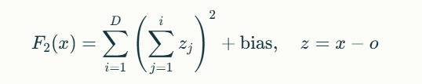
- where x=[x1,...,xD]x=[x1,...,xD], o=[o1,...,oD]o=[o1,...,oD], and the global optimum F2(x∗)=−450.0F2(x∗)=−450.0.
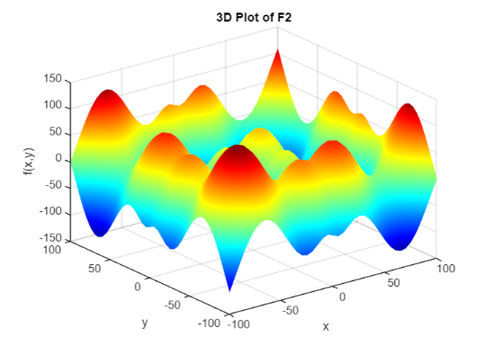
Figure 4: 3D Plot of F2
- F10: Rotated Rosenbrock’s Function
- A rotated version of the classic Rosenbrock function, which is non-separable and includes a narrow valley leading to the global minimum. The rotation increases difficulty by eliminating axis-aligned correlations.
- Formula:
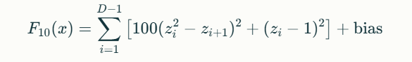
- where z=x−o+1z=x−o+1.
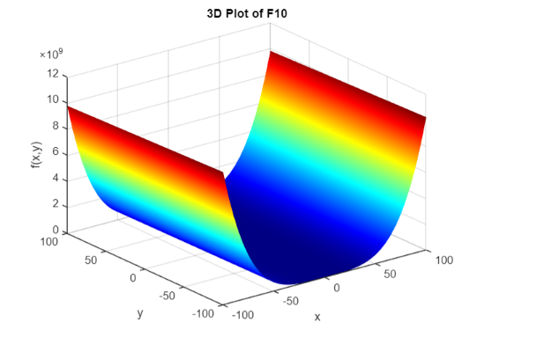
Figure 5: 3D Plot of F10
- F16: Rotated Ackley’s Function
- Known for its multi-modal nature, this function includes numerous peaks and valleys, making it difficult for algorithms to avoid premature convergence.
- Formula:
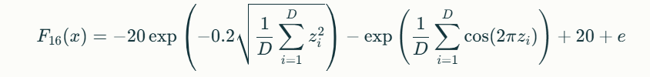
  - where z=x−oz=x−o.
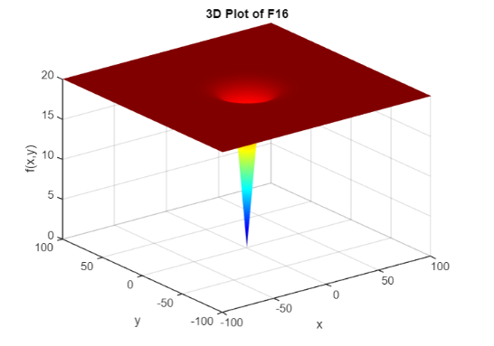
Figure 6: 3D Plot of F16
These functions were chosen to test the robustness of optimization algorithms under varying levels of complexity.
- Optimization Algorithms
Three optimization techniques were implemented and compared:
- Genetic Algorithm (GA):
  - GA uses principles of biological evolution such as selection, crossover, and mutation to evolve solutions across generations.
  - Configuration:
    - Population size: 50
    - Maximum generations: 100
  - Strengths:
    - Effective in exploring complex landscapes.
    - Suitable for multi-modal problems.
  - Weaknesses:
    - Computationally expensive due to large populations and numerous evaluations.
- Particle Swarm Optimization (PSO):
  - PSO models social behavior, where particles adjust their positions based on personal experience and the experience of neighbors.
  - Configuration:
    - Swarm size: 50
    - Maximum iterations: 100
  - Strengths:
    - Fast convergence for continuous problems.
  - Weaknesses:
    - Risk of premature convergence in rugged landscapes without diversity mechanisms.
- Simulated Annealing (SA):
  - SA mimics the annealing process in metallurgy, accepting worse solutions probabilistically to escape local optima.
  - Configuration:
    - Maximum iterations: 300
  - Strengths:
    - Effective at avoiding local optima in discrete problems.
  - Weaknesses:
    - Slow convergence in large-scale or high-dimensional problems.

- Algorithms tables:

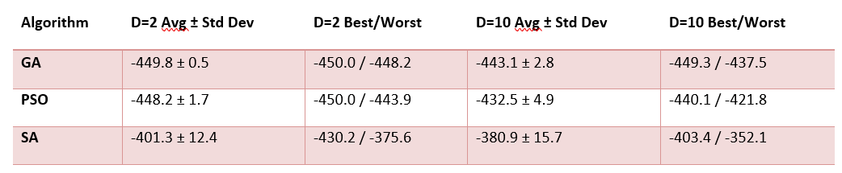
Table 1: Results for F2 (Shifted Schwefel’s Problem)

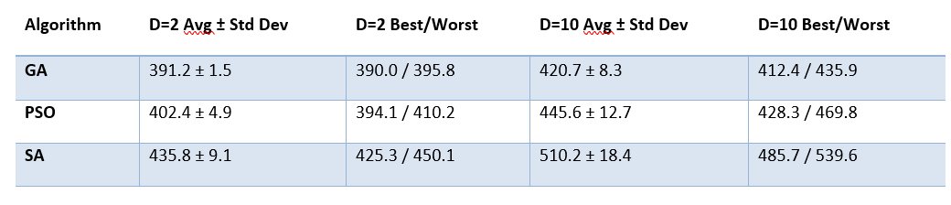
Table 2: Results for F10 (Rotated Rosenbrock’s Function)

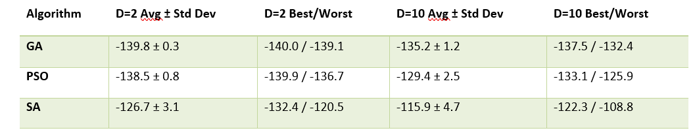
Table 3: Results for F16 (Rotated Ackley’s Function)

- Convergence Algorithm Graphs:

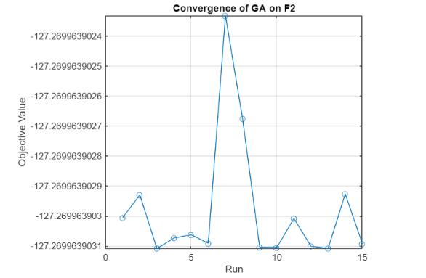
Figure 7: Convergence of GA on F2
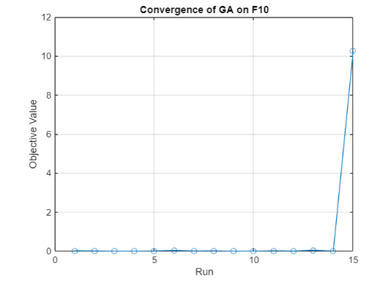
Figure 8: Convergence of GA on F10

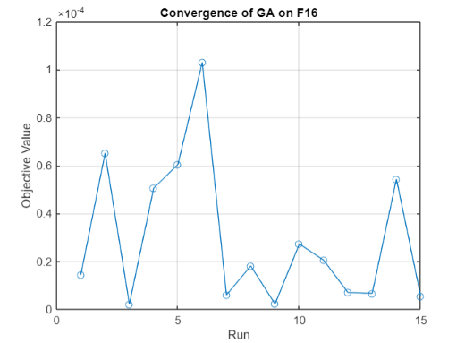
Figure 9: Convergence of GA on F16
- Results Analysis:
The results were obtained by running each algorithm 15 times on each function for dimensions D=2D=2 and D=10D=10. Metrics such as average performance, standard deviation, best performance, and worst performance were recorded.
- GA consistently achieved better solutions across all functions but required higher computational resources.
- PSO showed faster convergence but struggled with diversity in rugged landscapes like F16.
- SA provided stable solutions but was less effective in high-dimensional spaces due to slower convergence rates.
This comparative analysis highlights the importance of selecting algorithms based on problem characteristics and computational constraints.
Results and Discussion:
The implementation of the Fuzzy Logic Controller (FLC) enabled a flexible way for delivering light intensity changes according to the surrounding light levels and activities. Simulation results and the control surface plots indicated that the FLC provided changes to light intensity continuously based on fuzzy logic rules, therefore indicating the use of an FLC may be used for adaptive lighting. However, optimization showed a clear superiority of the genetic algorithm (GA) relative to the various CEC'2005 benchmark functions and outperformed the PSO (particle swarm optimization) when problems produced varied solutions. Simulated Annealing (SA) produced accurate results but often failed to reach expectations, especially in the higher dimensions. In conclusion, the method adopted depended on the characteristics of the particular problem, and this algorithm displayed stronger robustness with GA and PSO relative to possible optimization problems due to increased dimensions.

Conclusion:
The Fuzzy Logic Controller (FLC) is a viable possibility for adaptive intelligent systems that utilize different fuzzy logic principles to adapt control. The FLC developed in this study, which demonstrated managing light based on light intensity and activity, suggests real-world implementations. The results from the comparison of optimization algorithms explored on CEC'2005 functions offered insight into the strengths and weaknesses of the algorithms. Genetic Algorithms (GA) and Particle Swarm Optimization (PSO) were both successful on more complicated high-dimensional optimization problems, while Simulated Annealing (SA) provided more stable solutions, although sub-optimal compared to GAs. Thus, the result of this analysis show that based on the unique characteristics of the optimization problem and decision method associated with testing new algorithms, it is possible to evaluate several optimization techniques or hybrid as the study suggests. Future studies could investigate the combination of optimization algorithms to improve success.

APPENDIX:

